Customize the fields in User stories Reviewer Agent
For the Mandatory Assignment for the Week, Prompt Template MANDATORY TO APPLY ICEPOT TEMPLATE CREATING NEW PROMPT FOR SCORING MECHANISM (If you are customizing the prompt template and facing issues in formatting use chatgpt or any of the chat agents like qwen gemini etc its all we are practicing)

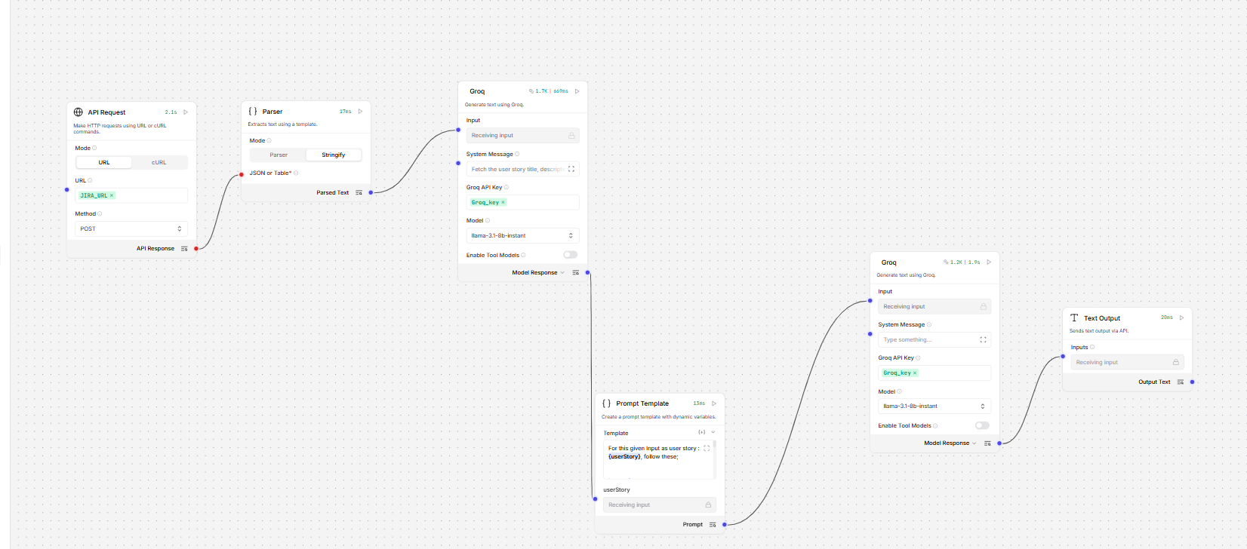
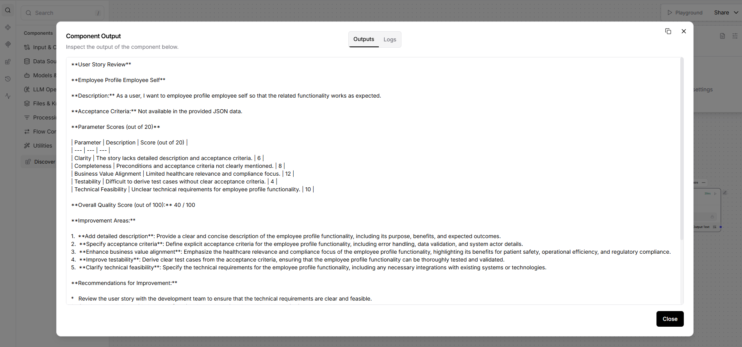
Run In postman –
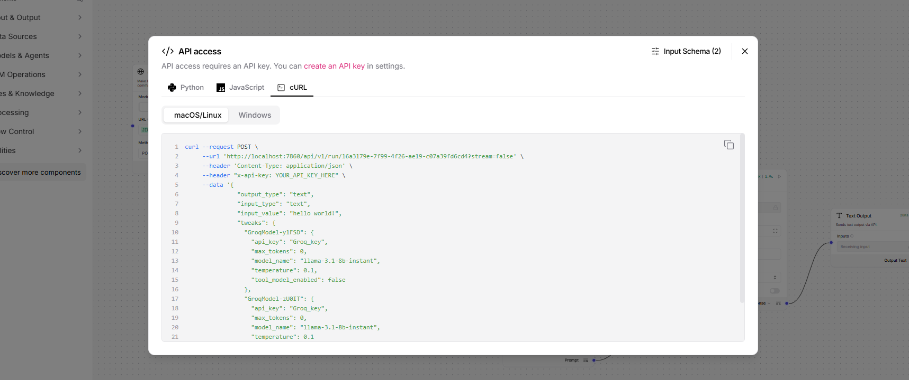
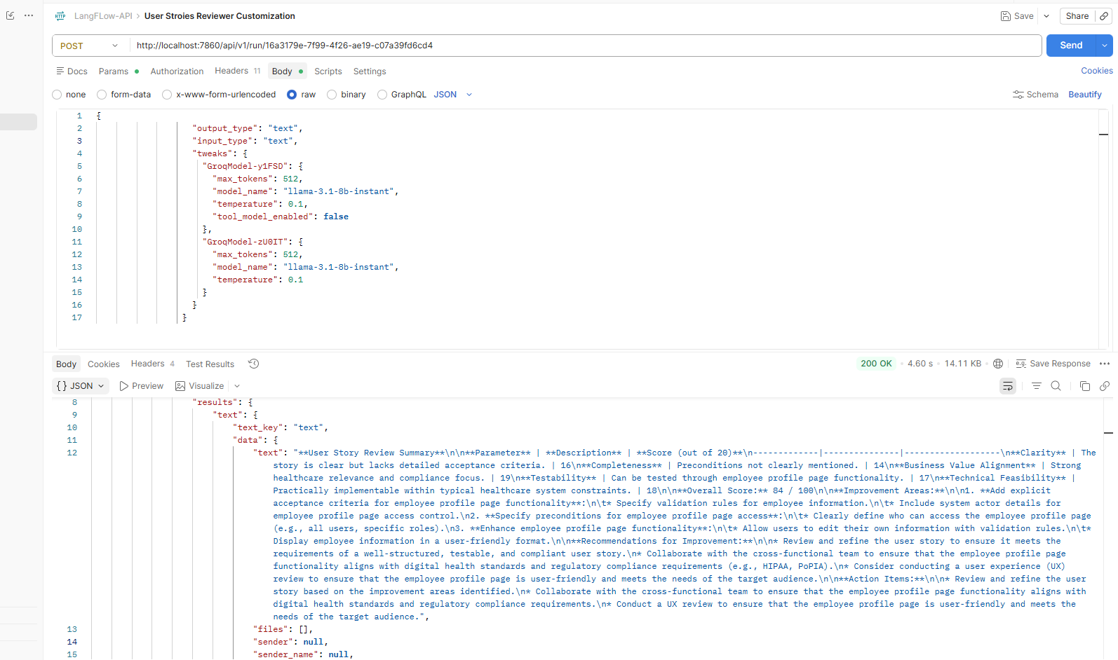

New Prompt –

TASK
You are an expert AI Business Analyst specializing in Healthcare IT systems.
Analyze the following User Story and provide a comprehensive quality review.
User Story:{userStory}
OBJECTIVE
Evaluate the user story against industry-standard Agile Business Analysis practices used in Healthcare projects involving:
- Electronic Health Records (EHR)
- Clinical Workflows
- Patient Management Systems
- Regulatory Compliance (HIPAA, PoPIA, HL7, FHIR)
- Hospital Operations
- Healthcare Data Security and Privacy
SCORING CRITERERIA
Evaluate the User Story on the following five parameters.
1. Clarity (20 Points)
- Is the story easy to understand?
- Is the language unambiguous?
- Are user roles and actions clearly defined?
- Are business rules understandable?

2. Completeness (20 Points)
- Are preconditions specified?
- Are acceptance criteria defined?
- Are assumptions documented?
- Are dependencies and exceptions identified?
- Are success and failure scenarios covered?

3. Business Value Alignment (20 Points)
- Does the story provide measurable healthcare value?
- Does it improve patient safety?
- Does it support regulatory compliance?
- Does it improve clinical efficiency?
- Does it support operational effectiveness?

4. Testability (20 Points)
- Can QA derive test cases directly?
- Are acceptance criteria measurable?
- Are validations clearly defined?
- Are positive, negative, and edge cases identifiable?

5. Technical Feasibility (20 Points)
- Is implementation realistic?
- Does it fit within common healthcare architecture constraints?
- Are integration requirements clear?
- Are security and compliance considerations addressed?

SCORING GUIDELINES
Use the following rating scale:
18-20 = Excellent
15-17 = Good
11-14 = Fair
0-10 = Needs Improvement

ANALYSIS REQUIREMENTS
For each parameter provide:
- Score (out of 20)
- Detailed assessment (2-4 sentences)
- Identified gaps
- Specific healthcare-focused recommendations
OVERALL ASSESSMENT
Calculate:
Overall Score = Sum of all parameter scores (out of 100)
Provide:
- Overall Quality Rating:
- Excellent (90-100)
- Good (75-89)
- Fair (60-74)
- Poor (<60)
- Key Strengths
- Key
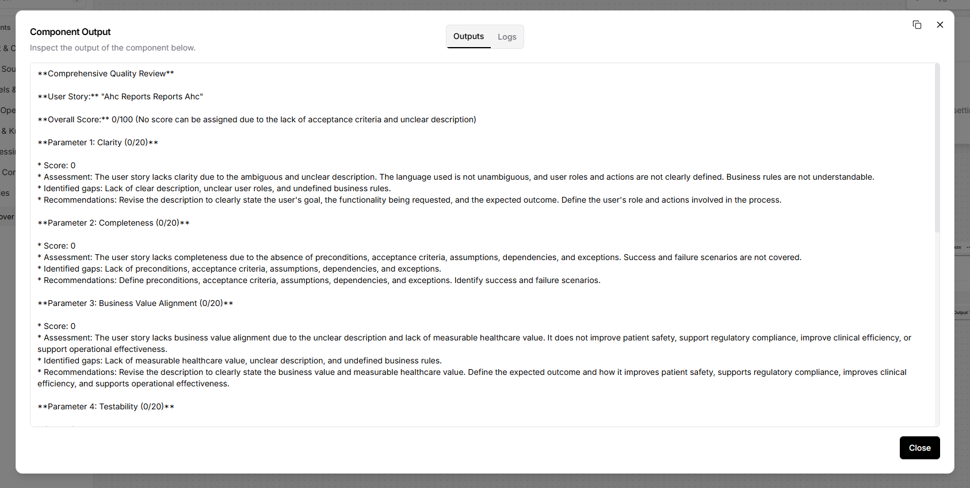
API –
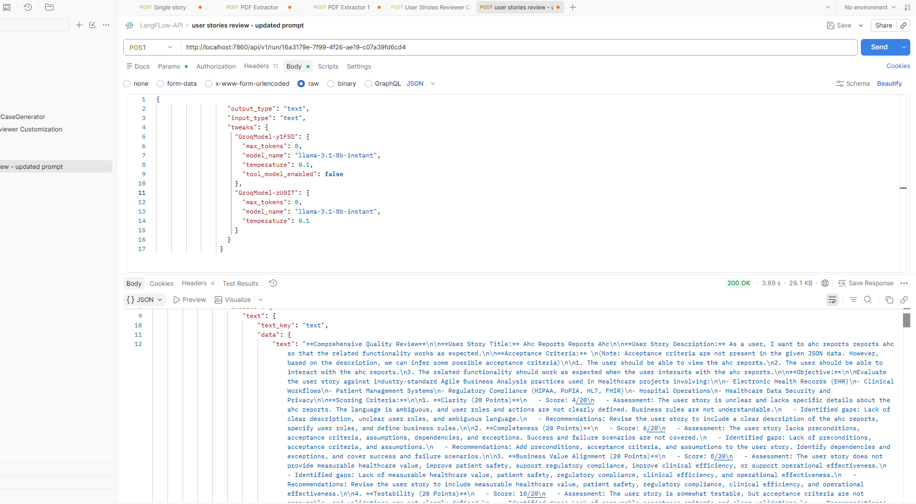
Beautify –
